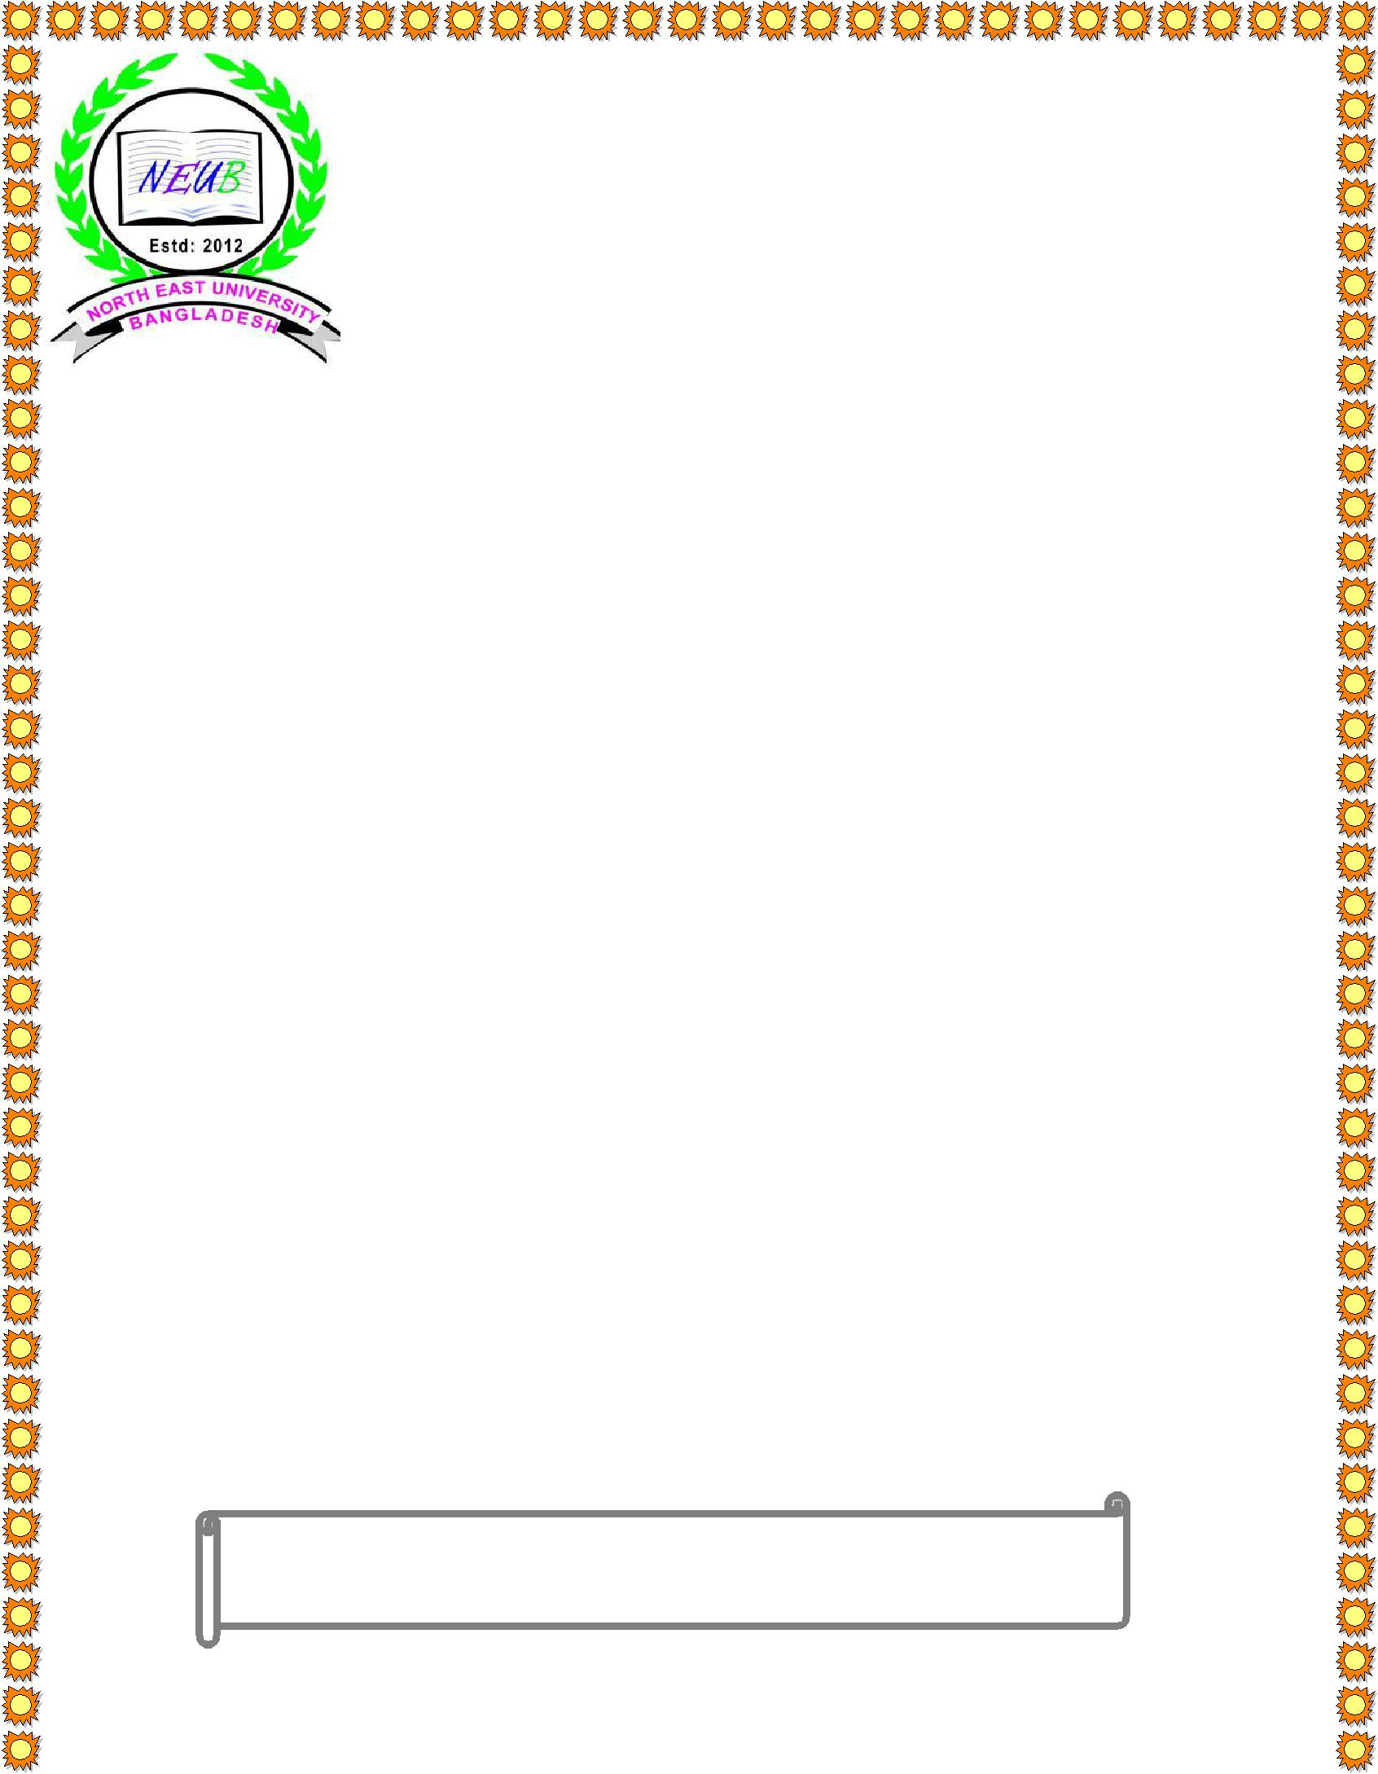

**North East University Bangladesh**

**Education with Innovation**

**Este: 2012**

**Team name : Ekta-Naam**

**Project name : Bangla Event Calender**

**Supervisor :**

**Noushad Sojib**

**Lecturer**

**Department of CSE**

**North East University Bangladesh**

**Submitted BY :**

**MD.Gulam Kibria Chowdhury**

ID No :- 170103020033

**Tania Sultana Mou**

ID No :- 170103020005

**Kutub Uddin**

ID No :- 170103020005 **North East University Bangladesh**

**SUBMITION DATE :- Sunday, 23 December 2018**



***Project Proposal***

***Bangla event calendar is a kind of calendar which given us the date between 1000 to 5000 years, in any event it’s show bangla date, year & valuable information(if event remain),and also shows current date & time. Using this calendar we’ll easily know which date is important & charming for our nationalism & country’s people. We also know the international day, many religion culture & also tribal culture. Bangla event calendar is helpful for gathering or knowing any important date & information.***

**Project Diagram :**